**Bangabandhu Sheikh Mujibur Rahman Science and Technology University, Gopalganj-8100.**



**Detection of Autism Spectrum Disorder using EEG Signals**

**Course Code : CSE478 28 November, 2023**

**By:** Tushar SarkarID:18CSE035

**Department of Computer Science and Engineering Bangabandhu Sheikh Mujibur Rahman Science and Technology University**

**Detection of Autism Spectrum Disorder using EEG Signals**

Submitted to the Department of Computer Science and Engineering, Bangabandhu Sheikh Mujibur Rahman Science and Technology University in partial fulfillment to the requirements for the degree of B.Sc. Engineering.

**By:** Tushar SarkarID:18CSE035

**Supervised By:**  Md. Ferdous Lecturer

**Department of Computer Science and Engineering Bangabandhu Sheikh Mujibur Rahman Science and Technology University**

# **DECLARATION**

I, **Tushar Sarkar** , **ID : 18CSE035** declare that the thesis consideration of degree of Bachelor of Computer Science and Engineering embodies our own work with suggestion received during the work which have been suitably acknowledge.

**Tushar Sarkar ID: 18CSE035**

…………………………. ………………….……...

Signature Date

# **APPROVAL**

I certify that this thesis “**Detection of Autism Spectrum Disorder using EEG Signals**” is the original work of the above named candidate and has been done under my supervision. To the best of my knowledge and belief, this work which embodies the work of candidates themselves, has been duly completed, fulfills the requirement of the ordinance relating to the fourth year of Bangabandhu Sheikh Mujibur Rahman Science and Technology University and is up to standard in respect of content, presentation and language for being referred to the examiner. The work has never been submitted anywhere. It’s only submitted to Bangabandhu Sheikh Mujibur Rahman Science and Technology University.

**Thesis Supervisor :**

**Md. Ferdous**

Lecturer

Department of Computer Science and Engineering

Bangabandhu Sheikh Mujibur Rahman Science and Technology University, Gopalganj.

Signature:……………………. Date:……………….

# **ACKNOWLEDGEMENT**

Firstly, I would like to express my deprest sense of gratitude to my reverend teacher and supervisors **Md. Ferdous**, Lecturer, Department of Computer Science and Engineering, Bangabandhu Sheikh Mujibur Rahman Science and Technology University and for his untiring guidance, constant supervision, enthusiastic encouragement, sagacious advice and an effective surveillance throughout the entire period of my project and preparation of the manuscript. I greatly say thank you. Wish to express my heart full thanks to all of my honorable teachers of the department of Computer Science and Engineering, Bangabandhu Sheikh Mujibur Rahman Science and Technology University.

Secondly, I would like to thank my department senior brother **Avilash Saha, ID:17CSE035** who helped me a lot in finalizing this thesis within a limited time frame.

Tushar Sarkar

18CSE035

28 November, 2023

# **ABSTRACT**

maagement in Institutes experience for both Students and the Adminstartion authorities. The whole

system will run on inte

Autism spectrum disorder is a neurodevelopmental disorder that affects social interaction and communication skills. Diagnosing ASD is one of the most difficult problems facing researchers, as can be understood from reading many thesis papers. This research work aims to reveal different patterns between autistic and normal children through EEG using deep learning algorithm. The brain signal database uses pattern recognition where the extracted features will go through the network for the classification process. A promising approach to perform classification is through a deep learning algorithm, which is currently a well-known and superior method in the field of pattern recognition. The performance measure for classification will be accuracy. A higher percentage means more efficacy for diagnosing ASD. This can be seen as ground work in applying a new algorithm to further diagnose autism to see how future treatments are working.

report entitled “Bank Account Management System” submitted to City University **TABLE OF CONTENT**

**Table of Contents**

**DECLARATION** 1

**APPROVAL** 2

**ACKNOWLEDGEMENT** 3

**ABSTRACT** 4

**CHAPTER – 1 INTRODUCTION** 6

**1.1 Introduction:** 6

**1.2 Background and Motivation:** 7

**1.3 Objectives:** 7

**CHAPTER – 2 RELATED LITERATURE REVIEW** 8

**CHAPTER – 3 RESEARCH METHODOLOGY** 9

**3.1 Research Type**: 9

**3.2 Data Sources and Description:** 10

**3.3 Research Methods:** 10

**CHAPTER – 4 EXPECTED RESULTS** 12

**CHAPTER – 5 SIGNIFICANCE AND IMPLICATIONS OF THE STUDY** 13

**CHAPTER – 6 CONCLUSIONS** 14

**CHAPTER – 7** **REFERENCES** 15

**Table of Figures**

Figure 1: EEG Signal from human brain 6

Figure 2: Research Method 11

# **CHAPTER - 1 INTRODUCTION**

## **1.1 Introduction:**

Autism Spectrum Disorder is a syndrome that adversely affect a child where the behavioral symptoms start to appear during the first year of life. This early childhood onset includes symptoms such as lack in social interaction and very slow language skills development as stated by researchers. A continuous characters and behavioral assessment is conducted by specialist in order to detect autistic presence in a child. A documented analysis done by pediatrics stated that, an autistic child at approximately 24 months, are still unable to produce two meaningful word that do not involve imitating and repeating. Despite so much research being conducted, the exact factors to why this disorder occurs remain unanswered. As of why this atypical behavior is very difficult to detect is maybe due to the barely noticeable changes of the primary neural impairment itself [1].

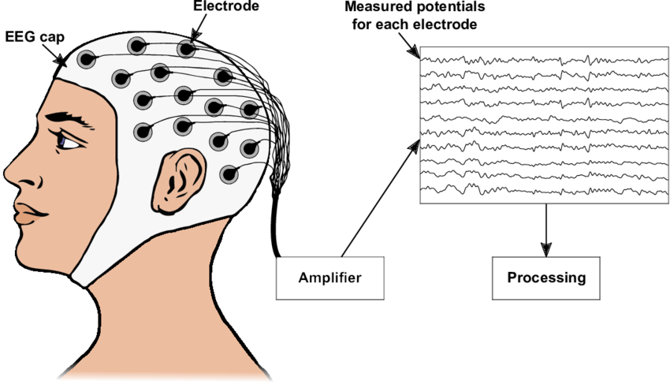

Figure 1: EEG Signal from human brain [[Link](https://www.google.com/url?sa=i&url=https%3A%2F%2Fwww.researchgate.net%2Ffigure%2FSketch-of-how-to-record-an-Electroencephalogram-An-EEG-allows-measuring-the-electrical_fig1_338423585&psig=AOvVaw0SQ4cVYqxk1zytpeK2PMOO&ust=1702443079613000&source=images&cd=vfe&opi=89978449&ved=0CBIQjRxqFwoTCNDE_O2MiYMDFQAAAAAdAAAAABAI)]

## **1.2 Background and Motivation:**

Current Autism Spectrum Disorder diagnostics based on behavioral assessments are subjective and time-consuming. The motivation lies in seeking objective biomarkers to enhance diagnostic precision and enable early intervention. The utilization of EEG signals presents an opportunity to augment traditional diagnostic approaches with quantitative and objective measures. EEG captures the electrical activity of the brain and can provide valuable insights into neural abnormalities associated with ASD. The motivation behind employing EEG for ASD detection lies in its non-invasive nature, high temporal resolution, and ability to capture real-time brain activity. By applying advanced signal processing techniques to extract meaningful features from EEG data, we aim to uncover distinctive patterns associated with ASD. This approach has the potential to contribute to the development of more reliable and efficient diagnostic tools.

## **1.3 Objectives:**

Introduce a new feature extraction method to detect ASD using EEG signals. Apply advanced signal processing for EEG data enhancement. Identify relevant features within EEG signals for ASD biomarkers. Develop machine learning algorithms for precise ASD classification. Reduce the number of EEG caps to collect better signals.

**The primary objectives of this research are as follows:**

**Feature Extraction from EEG Signals:** Develop robust methods for extracting relevant features from EEG signals that are indicative of ASD-related neural patterns.

**Model Development:** Utilize machine learning algorithms to build predictive models based on the extracted EEG features for accurate detection of ASD.

**Validation and Generalization:** Assess the performance of the developed models on diverse datasets to ensure their validity and generalizability across different populations.

# **CHAPTER - 2 RELATED LITERATURE REVIEW**

Researchers have found hopeful signs in using EEG to detect Autism Spectrum Disorder. One study noticed unique gamma frequency patterns, while another looked at the timing of brain responses. Another study used smart computer programs and achieved good results, but they pointed out that more testing across different groups is needed. Even though we've made progress, we still need to figure out the best way to use EEG for ASD diagnosis in different situations. And we will use Time Domain Feature in this research. Time domain features are extracted directly from the raw EEG signal in the time domain. These features provide information about the amplitude, variability, and statistical properties of the signal [2].

**Common Themes Across Studies:**

**Feature Importance:** Several studies highlight the importance of specific EEG features, such as features, in differentiating ASD from neurotypical individuals.

**Machine Learning Models:** The integration of machine learning models, as seen in emerges as a common approach, showcasing the potential for these models to enhance diagnostic accuracy.

**Ethical Considerations:** The recognition of ethical considerations in EEG-based ASD diagnosis is a recurring theme, emphasizing the need for responsible practices in research and potential clinical implementation.

# **CHAPTER - 3 RESEARCH METHODOLOGY**

We propose a hybrid lightweight deep feature extractor to obtain high classification performance. The system was designed and tested with a big EEG dataset that contained signals from autism patients and normal controls. In this work, features are extracted from EEG signal using one-dimensional local binary pattern and the generated features are utilized as input of the short time Fourier transform to generate. There are few feature extraction:

1. Time-domain feature extraction
2. Frequency-domain feature extraction
3. Decomposition-domain feature extraction
4. Joint time-frequency domain feature extraction
5. Spatial domain feature extraction
6. mRMR feature extraction
7. Higuchi’s fractal dimension feature extraction
8. Katz fractal dimension feature extraction
9. Petrosian fractal dimension feature extraction
10. Spectral entropy feature extraction
11. Permutation entropy feature extraction

## **3.1 Research Type**:

This study adopts a quantitative research approach to investigate the detection of Autism Spectrum Disorder through EEG signals. The quantitative approach allows for systematic analysis and numerical measurement, essential for objective assessments and the development of a machine learning model. The proposed research adopts a mixed-methods approach, combining quantitative and qualitative methodologies to provide a comprehensive understanding of EEG-based detection of Autism Spectrum Disorder. This approach allows for the extraction of meaningful features from EEG signals, the development of machine learning models, and an exploration of ethical considerations [3].

## **3.2 Data Sources and Description:**

The primary data source for this research comprises EEG recordings obtained from individuals diagnosed with ASD and neurotypical individuals. Ethical considerations will be paramount, and data will be collected from established clinical databases, research institutions, or through collaboration with medical professionals. The EEG recordings will capture brain activity during specific tasks or at rest, providing a comprehensive dataset for analysis.

**EEG Data Collection:** The primary data source is EEG recordings obtained from individuals diagnosed with ASD and neurotypical individuals. EEG data will be collected using specify EEG recording equipment, ensuring standardized acquisition protocols across participants. Inclusion criteria for participants will follow established diagnostic criteria for ASD, and efforts will be made to match demographic characteristics between ASD and control groups.

**Clinical and Demographic Information:** Complementary clinical and demographic information will be collected, including age, gender, and other relevant variables, to assess the impact of these factors on the EEG features.

**Ethical Considerations:** Informed consent will be obtained from all participants or their legal guardians. Ethical approval will be sought from the Institutional Review Board/Ethics Committee. Data anonymization and confidentiality measures will be implemented to protect participants' privacy.

## **3.3 Research Methods:**

This research methodology is designed to yield robust insights into EEG-based ASD detection, offering both quantitative predictions through machine learning models and qualitative perspectives on ethical considerations[.](https://www.ncbi.nlm.nih.gov/pmc/articles/PMC7749618/)

**Data Pre-processing:** Clean and preprocess the EEG data to address issues such as noise, artifacts, and outliers. Apply filtering techniques to remove unwanted frequencies and enhance relevant signal components. Standardize or normalize the data to ensure consistency across participants.

**Feature Extraction:** Extract relevant features from the pre-processed EEG data. Utilize advanced signal processing techniques to capture distinctive patterns associated with ASD. Features may include spectral power, coherence, and other time or frequency domain characteristics.

**Machine Learning Classification:** Develop machine learning models for the classification of individuals into ASD and neurotypical groups. Utilize algorithms such as support vector machines, random forests, or deep learning approaches. Train the models on the extracted features from the pre-processed EEG data.

**Cross-Validation:** Implement cross-validation techniques to evaluate the performance and robustness of the machine learning models. Split the dataset into training and testing subsets, repeating the process to ensure each subset is used for both training and testing. Assess metrics such as accuracy, precision, recall, and F1-score to gauge model performance [4].

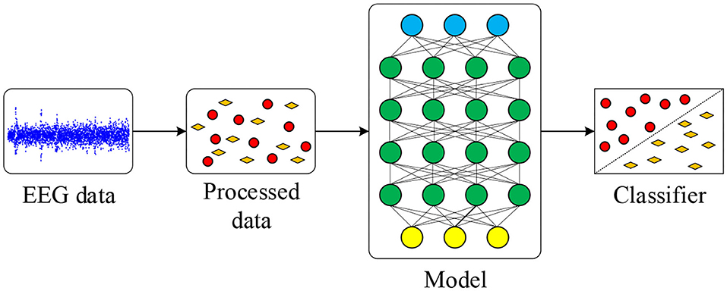

Figure 2: Research Method

# **CHAPTER - 4 EXPECTED RESULTS**

We aim to develop a machine learning model that effectively uses EEG signals to distinguish between individuals with Autism Spectrum Disorder. We expect that the new feature extraction model can demonstrate high accuracy and robustness, demonstrating its potential for practical application in early ASD detection. Additionally, we anticipate identifying specific EEG features that serve as reliable biomarkers for ASD, contributing valuable insights to the field. This may result in a more accurate and reliable classification model compared to existing methods.

# **CHAPTER - 5 SIGNIFICANCE AND IMPLICATIONS OF THE STUDY**

This research is crucial because it addresses the need for a more reliable and objective way to detect Autism Spectrum Disorder. By using EEG signals and developing a smart computer model, we aim to make the diagnosis process quicker and more accurate. The research is expected to advance our knowledge by identifying specific EEG features associated with ASD. This new understanding can contribute to a more precise and scientific approach to ASD diagnosis. The significance and implications of the study extend beyond the immediate domain of ASD research. By addressing a crucial public health concern, offering unique insights into neural mechanisms, and considering ethical dimensions, this research aims to make meaningful contributions to both the scientific community and healthcare practitioners. The study's limitations, while acknowledged, pave the way for future advancements in the field [5].

Our project is only a humble venture to satisfy the needs in an Institution. Several user-friendly

coding has also adopted. This package shall prove to be a powerful package in satisfying all the

requirements of the organization.

The objective of software planning is to provide a frame work that enables the manger to make

reasonable estimates made within a limited time frame at the beginning of the software project and

should be updated regularly as the project progresses. Last but not least it is no the work that played the

ways to success but ALMIGHTY

# **CHAPTER - 6 CONCLUSIONS**

The utilization of EEG signals represents an innovative and non-invasive approach to ASD diagnosis. By extracting discriminative features from EEG data, the project aims to uncover subtle neural patterns indicative of ASD, providing a more objective foundation for diagnosis. The research involves the application of advanced signal processing techniques and machine learning algorithms for feature extraction and model development. These technological advancements are anticipated to enhance the precision and reliability of ASD detection. The ultimate goal is to bridge the gap between research and clinical practice. Successful implementation of EEG-based diagnostic methods could significantly impact the early identification of ASD, leading to timely interventions and improved outcomes for individuals on the spectrum. The detection of Autism Spectrum Disorder by Feature Extraction of EEG Signals project holds the promise of making a lasting impact on the landscape of ASD diagnosis. By combining cutting-edge technology with a commitment to ethical practices and ongoing collaboration, the project aims to contribute significantly to the well-being of individuals with ASD and their families. As we embark on this research journey, we anticipate that our efforts will play a pivotal role in advancing the understanding and support for individuals on the autism spectrum.

# **CHAPTER - 7** **REFERENCES**

1. Ali NA, Syafeeza AR, Jaafar AS, Alif MK, Ali NA. Autism spectrum disorder classification on electroencephalogram signal using deep learning algorithm. IAES International Journal of Artificial Intelligence. 2020 Mar;9(1):91-9.
2. Baygin M, Dogan S, Tuncer T, Barua PD, Faust O, Arunkumar N, Abdulhay EW, Palmer EE, Acharya UR. Automated ASD detection using hybrid deep lightweight features extracted from EEG signals. Computers in Biology and Medicine. 2021 Jul 1;134:104548.
3. Alhassan S, Soudani A, Almusallam M. Energy-efficient EEG-based scheme for autism spectrum disorder detection using wearable sensors. Sensors. 2023 Feb 16;23(4):2228.
4. Zhao J, Song J, Li X, Kang J. A study on EEG feature extraction and classification in autistic children based on singular spectrum analysis method. Brain and behavior. 2020 Dec;10(12):e01721.
5. Posada-Quintero HF, Manjur SM, Hossain MB, Marmolejo-Ramos F, Lee IO, Skuse DH, Thompson DA, Constable PA. Autism spectrum disorder detection using variable frequency complex demodulation of the electroretinogram. Research in Autism Spectrum Disorders. 2023 Nov 1;109:102258.